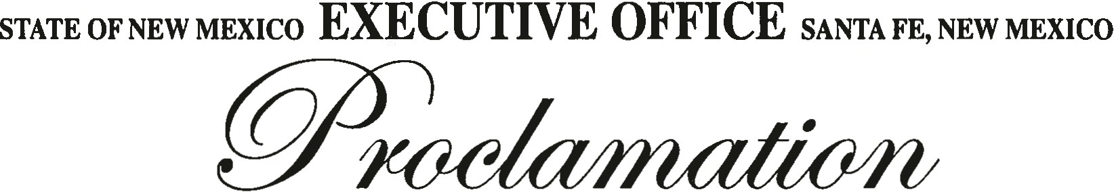

WHEREAS, THE "MODEL WHITE CANE LAW" WAS WRITIEN BY DR. JACOBUS TENBROEK, A DISTINGUISHED PROFESSOR OF LAW AND THE FIRST PRESIDENT OF THE NATIONAL FEDERATION OF THE BLIND; AND

WHEREAS, GOVERNOR DAVID CARGO SIGNED THE WHITE CANE LAW IN 1967, MAKING NEW MEXICO THE FIRST STATE IN THE NATION TO ADOPT THE MODEL WHITE CANE LAW; AND

WHEREAS, THE WHITE CANE LAW, NMSA 1978, SECTIONS 28-7-1 TO 28-7-7, DECLARES THAT IT IS THE POLICY OF THE STATE TO ENCOURAGE AND ENABLE PERSONS WHO ARE BLIND, VISUALLY IMPAIRED, OR WHO HAVE A DISABILITY TO PARTICIPATE FULLY IN THE SOCIAL AND ECONOMIC LIFE OF THE STATE AND TO ENGAGE IN REMUNERATIVE EMPLOYMENT; AND

WHEREAS, THE WHITE CANE LAW GIVES PERSONS WHO ARE BLIND, VISUALLY IMPAIRED, OR WHO HAVE A DISABILITY THE SAME RIGHT AS ALL CITIZENS TO THE FULL AND FREE USE OF THE STREETS, HIGHWAYS, SIDEWALKS AND OTHER PUBLIC PLACES; AND

WHEREAS, THE WHITE CANE LAW INCLUDES PERSONS WHO USE GUIDE DOGS, GIVING SUCH PERSONS THE SAME RIGHT TO SAFE AND FUNCTIONAL USE OF PUBLIC FACILITIES, PLACES OF PUBLIC ACCOMMODATION, AND OTHER PLACES TO WHICH THE PUBLIC IS INVITED;

NOW, THEREFORE I, SUSANA MARTINEZ, GOVERNOR OF THE STATE OF NEW MEXICO, DO HEREBY PROCLAIM THE 15th DAY OF OCTOBER 2011 AS

''WHITE CANE SAFETY DAY''

THROUGHOUT THE STATE OF NEW MEXICO; AND ENCOURAGE THE CITIZENS OF NEW MEXICO TO BE AWARE OF THE WHITE CANE LAW, AND THEIR RESPONSIBILITY IN UPHOLDING IT; TO BE AWARE THAT PERSONS WITH DISABILITIES HAVE MUCH TO OFFER AND THEIR ENERGY, CREATIVITY, AND HARD WORK CAN GREATLY STRENGTHEN OUR STATE AND OUR ECONOMY; AND TO RECOGNIZE THAT THE WHITE CANE IS AN INSTRUMENT OF SAFETY AND INDEPENDENCE FOR PERSONS WHO ARE BLIND OR VISUALLY IMPAIRED.

SIGNED AT THE EXECUTIVE OFFICE THIS 7TH DAY OF OCTOBER 2011.

WITNESS MY HAND AND THE GREAT SEAL OF THE STATE OF NEW MEXICO.

SUSANA MARTINEZ GOVERNOR
DIANNA J. DURAN SECRETARY OF STATE

